2022 Wildfire Smoke Response Plan Template
Adapted from Washington Administrative Code (WAC) 296-62-085 Wildfire Smoke.
Employer Instructions: Use this document to help you comply the Wildfire Smoke Emergency Temporary Standard, WAC 296-62-085, effective June 15, 2022 and expiring on September 29, 2022.
Edit this template to reflect your workplace’s current safety practices. Text highlighted in yellow contains guidance information and can be deleted once that guidance is followed. This template contains form fields where you are to specify how these requirements are being met in your workplace.

Scope of the Emergency Wildfire Smoke Rule
The Emergency Wildfire Smoke Rule WAC 296-62-085 applies to workplaces where the employer should reasonably anticipate that employees may be exposed to a PM_{2.5} of 20.5 µg/m³ (Air Quality Index 69 (AQI 69)) or more for wildfire smoke.

The following workplaces and operations are exempt from this section:
- Enclosed buildings or structures in which the employer ensures that windows, doors, bays, and other exterior openings are kept closed, except when it is necessary to briefly open doors to enter and exit.
- Enclosed vehicles in which the air is filtered by a properly maintained cabin air filter and the employer ensures that windows, doors, and other openings are kept closed except when it is necessary to briefly open doors to enter or exit.
- Employees exposed to a PM_{2.5} concentration of 20.5 µg/m³ (AQI 69) or more for a total of one hour or more during a 24-hour period.
- Work within the scope of chapter 296-305 WAC, Safety standards for firefighters.

Introduction
We recognize wildfire smoke to be a health hazard for our employees when it is smoky. This wildfire smoke plan outlines actions we are taking to protect our employees from wildfire smoke.

A summary of the requirements of the Emergency Wildfire Smoke Rule, WAC 296-62-085
Employers of employees who may be exposed to wildfire smoke must:
- Check the current PM_{2.5} before and periodically during each shift.
- Provide training to employees.
- Implement a two-way communication system.
- Provide engineering and administrative controls when the current PM_{2.5} is 35.5 μg/m³ (AQI 101) or more if feasible.
- Provide respirators and encourage their use when the current PM_{2.5} is 35.5 μg/m³ (AQI 101) or more.
- Provide more protective respirators such as powered air purifying respirators, and require their use when the current PM_{2.5} is 555 µg/m³ or more.
Employers must alert employees when at least two consecutive current PM_{2.5} readings are 20.5 μg/m³ (AQI 69) or more, when the current PM_{2.5} is 35.5 μg/m³ (AQI 101) or more, and when the current PM2.5 is 555 µg/m³ or more, and what protective measures are available to employees.
Employers must encourage employees to inform their employers if they notice the air quality is getting worse, or if they are suffering from any symptoms due to the air quality, without fear of reprisal.
Employers must take action to protect employees from wildfire smoke when the current PM_{2.5} is 35.5 μg/m³ (AQI 101) or more. Examples of protective methods include:
- Locating work in enclosed structures or vehicles where the air is filtered.
- Changing procedures such as moving workers to a place with a lower PM_{2.5}.
- Reducing work time in areas with unfiltered air.
- Increasing rest time and frequency, and providing a rest area with filtered air.
- Reducing the physical intensity of the work to help lower the breathing and heart rates.

Health Effects of Wildfire Smoke
Although there are many hazardous chemicals in wildfire smoke, the main harmful pollutant for people who are not very close to the fire is "particulate matter," the tiny particles suspended in the air.
Particulate matter can irritate the lungs and cause persistent coughing, phlegm, wheezing, or difficulty breathing. Particulate matter can also cause more serious problems, such as reduced lung function, bronchitis, worsening of asthma, heart failure, and early death.
Sensitive groups. People who are at higher risk of experiencing adverse health effects as a result of exposure to wildfire smoke include those with preexisting health conditions; those with increased duration of exposure; and those whose work results in an increased breathing rate, including outdoor workers. Although everyone is impacted by wildfire smoke exposure, sensitive groups are among those most likely to experience health problems from exposure to wildfire smoke. Examples of sensitive groups include:
- People with lung diseases such as asthma or chronic obstructive pulmonary disease (COPD), including bronchitis and emphysema, and those who smoke;
- People with respiratory infections, such as pneumonia, acute bronchitis, bronchiolitis, colds, flu, or those with, or recovering from COVID-19;
- People with existing heart or circulatory problems, such as irregular heart beat, congestive heart failure, coronary artery disease, angina, and those who have had a heart attack or stroke;
- Children under 18 years old, and adults over age 65;
- People who are pregnant;
- People with diabetes;
- People with other medical or health conditions that can be exacerbated by exposure to wildfire smoke as determined by a physician;
- Outdoor workers.
The Washington state department of health classifies outdoor workers as a sensitive group with increased risk, as well as:
- People with health conditions:
-Lung diseases, such as asthma and COPD;
-Heart diseases;
-Respiratory diseases;
-Diabetes.
- People 18 and younger, or older than 65;
- Pregnant people;
- People of color;
- Tribal and indigenous people;
- People with low income.

Identification of harmful exposures
We will determine employee exposure to fine particulate matter, or PM_{2.5}, in the air before each shift and periodically thereafter, as needed to protect the health of our workers. We will use one of the following methods (check the appropriate box(es) to indicate the method(s) used to determine employee exposure to PM_{2.5}. Air Quality Index, or AQI, measurements can be used to aproximate PM_{2.5}.):

Online/mobile resources
☐ Washington Department of Ecology – web/mobile app
☐ Washington Smoke Information – web
☐ U.S. Environmental Protection Agency (EPA) AirNow – web/mobile app
☐ U.S. Forest Service AirFire – web
☐ Local Clean Air Agency – web specify: Click or tap here to enter text.

Other resources (phone/email/text message/etc.)
☐ Washington Department of Ecology
☐ Local Clean Air Agency specify: Click or tap here to enter text.
☐ U.S. EPA
☐ EPA EnviroFlash.info
☐ PM_{2.5} levels measured by employer specify method(s): Click or tap here to enter text.

PM_{2.5} in micrograms per cubic meter (µg/m³) | Air Quality Index for PM_{2.5} (AQI)
20.5 µg​/m³ | AQI 69
35.5 µg​/m³ | AQI 101
555 µg​/m³ | Beyond the AQI

Communicating the dangers of wildfire smoke
We will communicate wildfire smoke hazards to our employees when the air quality is at or above 20.5 μg/m³ (AQI 69). We encourage our employees to use one of the resources listed above to monitor the air quality where they are working and to notify their supervisor when the air quality is above 20.5 μg/m³ (AQI 69).

Informing employees
Describe how you will inform employees of the following:
- When at least two consecutive current PM_{2.5} readings are 20.5 μg/m³ (AQI 69) or more.
- When the current PM_{2.5} is 35.5 μg/m³ (AQI 101) or more.
- Available protective measures to reduce employees’ wildfire smoke exposure.
Click or tap here to enter text.

Encouraging employees to report wildfire smoke hazards and symptoms
We will not punish employees who show signs of injury or illness due to wildfire smoke exposure for seeking medical treatment. Describe how you will enable, and encourage employees to report worsening air quality and adverse symptoms that may be the results of wildfire smoke exposure:
Click or tap here to enter text.

Information and training
Our employees will be trained on wildfire smoke prior to any work that will expose them to PM_{2.5} levels of 20.5 μg/m³ (AQI 69) or more, and at least annually thereafter.

Employee training
Describe how you will provide employees with the required wildfire smoke safety training. L&I has provided an online training material that can help meet this requirement. You may also develop your own customized training. Appendix B of the Emergency Wildfire Smoke Rule WAC 296-62-085 provides information to be provided to employees.
Click or tap here to enter text.

Supervisor training
Describe how you will provide supervisors with the required wildfire smoke safety training. The wildfire smoke safety course provided by L&I will only partially meet this requirement. Supervisors must also be trained on the following topics:
- The procedures the supervisor must follow to implement the applicable provisions of WAC 296-62-085 Wildfire Smoke;
- The procedures the supervisor must follow if an employee exhibits adverse symptoms of wildfire smoke exposure, including appropriate emergency response procedures; and
- Procedures for moving or transporting employees to an emergency medical service provider, if necessary.
Click or tap here to enter text.

Exposure symptom response
We will monitor employees displaying adverse symptoms of wildfire smoke exposure to determine whether medical attention is necessary.
We will allow and support employees who show signs of injury or illness due to wildfire smoke exposure to seek medical treatment. We will not retaliate against affected employees for seeking such treatment.
We will have effective provisions made in advance for prompt medical treatment of employees in the event of serious injury or illness caused by wildfire smoke exposure.
Explain the provisions in your workplace to provide employees with prompt medical treatment for symptoms of wildfire smoke exposure:
Click or tap here to enter text.

Exposure controls
When the PM_{2.5} level is 35.5 µg/m³ (AQI 101) or more, we will implement exposure controls whenever feasible.
Describe the engineering and administrative controls to reduce wildfire smoke exposure among your employees. Where the PM_{2.5} is 20.5 µg/m³ (AQI 69) or more, employers are encouraged to implement exposure controls. Some exposure control examples include:
- Providing enclosed buildings, structures, or vehicles where the air is adequately filtered.
- Providing portable HEPA filters in enclosed areas.
- Relocating work to a location with a lower ambient air concentration of PM_{2.5}.
- Changing work schedules to a time with a lower ambient air concentration of PM_{2.5}.
- Reducing work intensity.
- Providing additional rest periods.

Click or tap here to enter text.

Respiratory Protection
When the PM_{2.5} is 35.5 µg/m³ (AQI 101) or more, we will provide respirators at no cost to all employees, and we will encourage employees to use those respirators.
When the PM_{2.5} is 555 µg/m³ or more, employees must be enrolled in a complete respiratory protection program in accordance with chapter 296-842 WAC prior to working in these conditions. Respirators worn in these conditions must have high efficiency particulate air filters and be:
- Loose-fitting powered air purifying respirators,
- Full-facepiece air purifying respirators,
- Full-facepiece powered air purifying respirators, or
- Other respirators that are at least as effective.
These respirators are more protective than N95s. You will need to have a fit test, medical evaluation, and must be clean shaven to use these respirators, except for loose-fitting powered air purifying respirators (PAPR), which can be worn without a fit test, and can be used with facial hair.
Explain your procedures for providing employees with voluntary use respirators when you are recommended and/or required to do so as described above. Include the type(s) of respirators used and work practices for respirator maintenance and storage. When the PM_{2.5} is 20.5 µg/m³ (AQI 69) or more, employers are encouraged to provide respirators at no cost to employees upon request. Explain your procedures/plans for when the PM_{2.5} is 555 µg/m³ or more. Review the requirements for voluntary respirator use in WAC 296-842.
Click or tap here to enter text.

The importance, limitations, and benefits of using a properly fitted respirator when exposed to wildfire smoke.
Respirators can be an effective way to protect employee health by reducing exposure to wildfire smoke, when they are properly selected and worn. Respirator use can be beneficial even when the PM_{2.5} is less than 20.5 μg/m³, to provide additional protection.
A respirator needs to be used properly and kept clean.
The following precautions must be taken:
- We will select respirators certified for protection against the specific air contaminants at the workplace. NIOSH, the National Institute for Occupational Safety and Health of the U.S. Centers for Disease Control and Prevention certifies respirators. A label or statement of certification should appear on the respirator or respirator packaging. It will list what the respirator is designed for (particulates, for example). Surgical masks or items worn over the nose and mouth such as scarves, T-shirts, and bandannas will not provide protection against wildfire smoke. A NIOSH approved N95 filtering facepiece respirator, shown in the image below, is the minimum level of protection for wildfire smoke.
- Read and follow the manufacturer's instructions on the respirator's use, maintenance, cleaning and care, along with any warnings regarding the respirator's limitations. The manufacturer's instructions for medical evaluations, fit testing, and shaving should also be followed to ensure the best protection against wildfire smoke.
- Do not wear respirators in areas where the air contains contaminants for which the respirator is not designed. A respirator designed to filter particles will not protect you against gases or vapors, and it will not supply oxygen.
- You should keep track of your respirator so you do not mistakenly use someone else's respirator.
- Particularly if you have a heart or lung problem, or if you have other medical problems and have questions about whether it is safe for you to wear a respirator, you should talk to your doctor.

How to properly put on, use, and maintain the respirators
To get the most protection from a respirator, there must be a tight seal around the face. A respirator will provide much less protection if facial hair interferes with the seal. Loose-fitting powered air purifying respirators may be worn by people with facial hair since they do not have seals that are affected by facial hair.
The proper way to put on a respirator depends on the type and model of the respirator. For those who use an N95 or other filtering facepiece respirator that is made of filter material:
(a) Place the mask over the nose and under the chin, with one strap placed below the ears and one strap above.
(b) Pinch the metal part (if there is one) of the respirator over the top of the nose so it fits securely.
(c) Perform a seal check:
(i) Cover the respirator with both hands and exhale. If air leaks where the respirator seals against the face, adjust the respirator and nosepiece and try again. When a proper fit is achieved, the respirator should bulge from the face and not leak around the seal.
(ii) Cover the respirator with both hands and inhale. If air leaks where the respirator seals against the face, adjust the respirator and nosepiece and try again. When a proper fit is achieved, the respirator should collapse slightly and not leak around the seal.

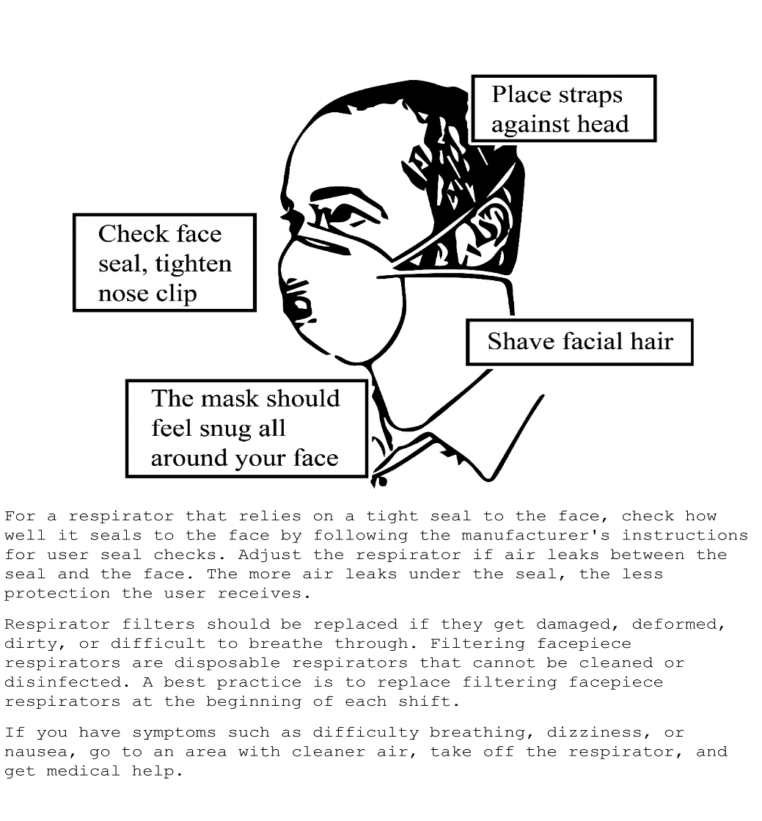
Insert how to properly put on, use, and maintain the respirators you provide to your employees if different from an N95.
Click or tap here to enter text.

https://doh.wa.gov/sites/default/files/legacy/Documents/4300//waqa%20infographic_English.pdf

